Assignment No. 1

Subject: Object Oriented Programming

Code: CSEG 2016

Program/Branch: B.Tech/CSE-DevOps

Term/Sec: IV/DevOps

Faculty: Pushpendra K Rajput

Session: 2019-2020

Submitted By:- Anurag Mor

Roll Number And Sap ID:- R171218025 And 500069361

Q.1 Create the abstract class Animal and a set of two or three animal sub-classes such as Tiger.

Solution:-

class Animals

{

String name;

int age;

String getname()

{

return name;

}

int getage()

{

return age;

}

void talk()

{

System.out.println("Hello");

}

}

class Lion extends Animals

{

Lion(String n, int a)

{

this.name=n;

this.age=a;

}

void talk()

{

System.out.println("Name of the animal is "+name+"\n"+"Age of the animal is "+age);

System.out.println("Type::Animal is a Lion");

}

}

class Tiger extends Animals

{

Tiger(String n, int a)

{

this.name=n;

this.age=a;

}

void talk()

{

System.out.println("Name of the animal is "+name+"\n"+"Age of the animal is "+age);

System.out.println("Type::Animal is a Tiger");

}

}

class Other_Animals extends Animals

{

Other_Animals(String n, int a)

{

this.name=n;

this.age=a;

}

void talk()

{

System.out.println("Name of the animal is "+name+"\n"+"Age of the animal is "+age);

System.out.println("Type::Other's");

}

}

class Zoo

{

static int i=0;

int j;

Animals[] array1 = new Animals[10];

{

for(j=0;j<10;j++)

{

array1[j]= new Animals();

}

}

void addanimal(String n, int a, int ani)

{

if(ani==1)

{

array1[i]=new Lion(n,a);

i=i+1;

}

else if (ani==2)

{

array1[i]=new Tiger(n,a);

i=i+1;

}

else if (ani==3)

{

array1[i]=new Other_Animals(n,a);

i=i+1;

}

}

void displayanimals()

{

String dname;

int c;

System.out.println("Animals in the zoo are");

for(c=0;c<i;c++)

{

dname= array1[c].getname();

System.out.println(dname);

}

}

void display()

{

String dname;

int dage;

int c;

for(c=0;c<i;c++)

{

dname= array1[c].getname();

dage= array1[c].getage();

System.out.println("Name of the animal is "+dname);

System.out.println("Age of the animal is "+dage);

}

}

void feedingtime()

{

int c;

for(c=0;c<i;c++)

{

array1[c].talk();

}

}

}

public class Question1

{

public static void main (String args[])

{

String name;

int age,t,choice;

Zoo zobj = new Zoo();

Scanner sc = new Scanner(System.in);

do

{

System.out.println("Press 1 to add a new animal to the zoo");

System.out.println("Press 2 to display all the animals in the zoo");

System.out.println("Press 3 to display all the name and age of the animal in a selected type");

System.out.println("Press 4 to trigger the feeding time");

int a =sc.nextInt();

sc.nextLine();

switch(a)

{

case 1:

{

System.out.println("Enter the name of the Animal");

name= sc.nextLine();

System.out.println("Enter the age of the Animal");

age= sc.nextInt();

System.out.println("Enter the type of Animal\n1 for lion \n2 for tiger \n3 for other ");

t= sc.nextInt();

zobj.addanimal(name , age , t);

break;

}

case 2:

{

zobj.displayanimals();

break;

}

case 3:

{

zobj.display();

break;

}

case 4:

{

zobj.feedingtime();

}

default:

{

System.out.println("Invalid choice");

}

}

System.out.println("Do u want to continue Press 1 to continue");

choice= sc.nextInt();

}while(choice==1);

}

}

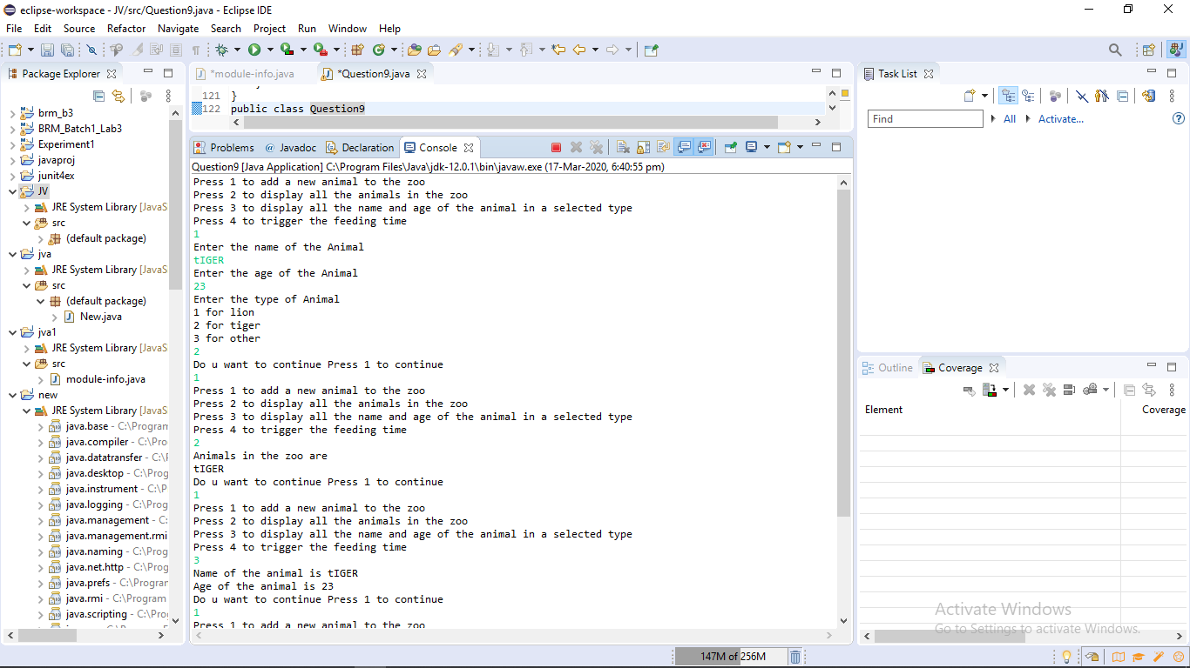

Q.2 Create a class Rectangle. The class has attributes length and width, each of which defaults to 1. It has member functions that calculate the perimeter and the area of the rectangle.

Solution:-

import java.util.*;

import java.lang.Math;

class MyException extends Exception

{

public MyException(String s)

{

super(s);

}

}

class Rectangle

{

double ab , bc, cd, ad;

float length=1.0f;

float width=1.0f;

double getlength(float x1, float y1 , float x2, float y2)

{

double l;

l=Math.sqrt(((x2-x1)*(x2-x1) + (y2-y1)*(y2-y1)));

return l;

}

void set(float[] array)

{

int i;

for(i=0;i<8;i++)

{

try

{

if(array[i] < 0.0 || array[i] >20.0)

{

throw new MyException("Invalid value ");

}

}

catch (MyException ex)

{

System.out.println("Invalid value of Co-ordinates, that is Greater than 20.0 or less than 0.0");

}

}

ab=getlength(array[0],array[1],array[2],array[3]);

bc=getlength(array[2],array[3],array[4],array[5]);

cd=getlength(array[4],array[5],array[6],array[7]);

ad=getlength(array[6],array[7],array[0],array[1]);

System.out.println("Sides are"+ab+" "+bc+" "+cd+" "+ad);

try

{

if(ab!=cd || bc!=ad)

{

throw new MyException("Invalid");

}

}

catch (MyException ex)

{

System.out.println("Error:: Coordinates do not form a Rectangle");

}

}

Rectangle(float length, float width, float[] arr)

{

try

{

if(length < 0.0 || length > 20.0)

{

throw new MyException("Invalid value of Length (Does not fullfill the conditions");

}

if(width < 0.0 || width > 20.0)

{

throw new MyException("Invalid value of Width (Does not fullfill the conditions)");

}

}

catch (MyException ex)

{

System.out.println("Invalid value of Length or Breath");

}

set(arr);

}

void perimeter()

{

double p;

p=2*(ab+bc);

System.out.println("Perimeter of the rectangle is"+p);

}

void area()

{

double a;

a= ab*bc;

System.out.println("Area of the rectangle is "+a);

}

void length()

{

double l,w;

if(ab > bc)

{

l=ab;

w=bc;

}

else

{

l=bc;

w=ab;

}

System.out.println("Length of the Rectangle is "+l);

System.out.println("Width of the Rectangle is "+w);

}

}

public class Question2

{

public static void main(String[] args)

{

float l=1.0f,w=1.0f;

Scanner sc = new Scanner(System.in);

System.out.println("Enter the length of the rectangle");

l= sc.nextInt();

System.out.println("Enter the width of the rectangle");

w= sc.nextInt();

System.out.println("Enter the coordinates of rectangle");

int i,k=0;

float[] array1 = new float[8];

for(i=1;i<=4;i++)

{

System.out.println("x"+i+"=");

array1[k]=sc.nextInt();

k++;

System.out.println("y"+i+"=");

array1[k]=sc.nextInt();

k++;

}

Rectangle obj = new Rectangle(l,w,array1);

obj.perimeter();

obj.area();

obj.length();

}

}

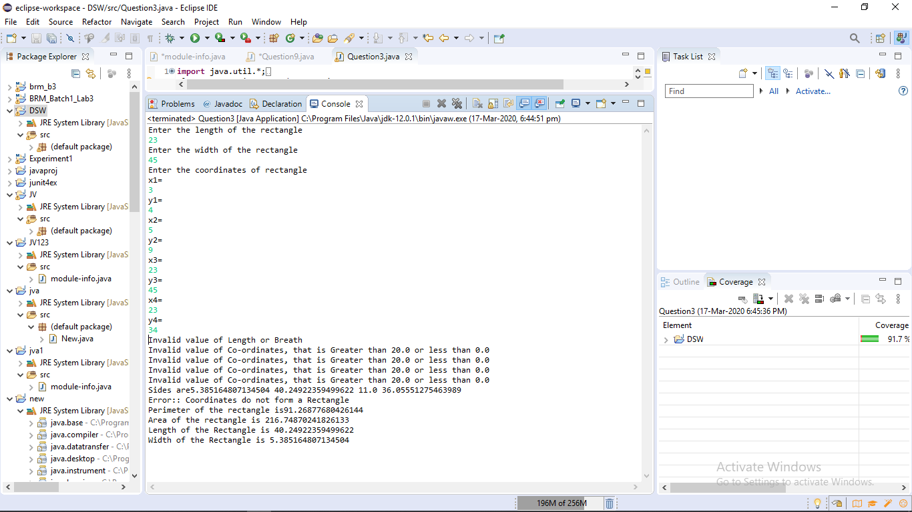

Q.3 Imagine a publishing company that markets both book and audio cassette versions of its works.

Solution:-

import java.util.Scanner;

interface Sales

{

public void getsales();

public void displaysales();

}

class Publications

{

float price;

String title;

Publications()

{

System.out.println("Constructor of Publications Class called");

}

Publications(float p,String t)

{

price=p;

title=t;

}

void display()

{

System.out.println("Display function");

}

public void finalize()

{

System.out.println("Destructor of Publications Class called");

}

}

class Book extends Publications implements Sales

{

Scanner sc = new Scanner(System.in);

double amount;

int pagecount,salecount;

Book()

{

System.out.println("Constructor of Book Class called");

}

Book(float p, String t,int pc)

{

super(p,t);

pagecount=pc;

}

public void getsales()

{

System.out.println("Enter the total sale of books");

salecount= sc.nextInt();

}

public void displaysales()

{

amount= salecount*price;

System.out.println("Total amount of sales is "+amount);

}

void display()

{

System.out.println("\n Name of the book is :"+title+"\nPrice of the book is "+price+"\nPage count of the book is "+pagecount);

}

public void finalize()

{

System.out.println("Destructor of books Class called");

}

}

class Tape extends Publications implements Sales

{

Scanner sc = new Scanner(System.in);

float playingtime,salecount;

double amount;

Tape()

{

System.out.println("Constructor of Tape Class called");

}

Tape(float p, String t, float time)

{

super(p,t);

playingtime=time;

}

public void getsales()

{

System.out.println("Enter the total sale of Tape");

salecount= sc.nextInt();

}

public void displaysales()

{

amount= salecount*price;

System.out.println("Total amount of sales is "+amount);

}

void display()

{

System.out.println("\n Name of the Tape is :"+title+"\nPrice of the Tape is "+price+"\nTime of the Tape is "+playingtime);

}

public void finalize()

{

System.out.println("Destructor of Tape Class called");

}

}

public class Question3 {

public static void main(String[] args)

{

System.out.println("The order of Constructor and Destructor Invocation is");

Publications obj1 = new Book();

obj1.finalize();

Publications obj2 = new Tape();

obj2.finalize();

Scanner sc = new Scanner(System.in);

System.out.println("Enter the name of the book");

String name= sc.nextLine();

System.out.println("Enter the price of the book");

Float price = sc.nextFloat();

System.out.println("Enter the page count of the book");

int count = sc.nextInt();

Book obj3 = new Book(price,name, count);

obj3.display();

sc.nextLine();

System.out.println("Enter the name of the Tape");

String Tname= sc.nextLine();

System.out.println("Enter the price of the Tape");

Float Tprice = sc.nextFloat();

System.out.println("Enter the Time of the tape");

float Ttime = sc.nextFloat();

Tape obj4 = new Tape(Tprice, Tname, Ttime);

obj4.display();

obj3.getsales();

obj3.displaysales();

obj4.getsales();

obj4.displaysales();

}

}

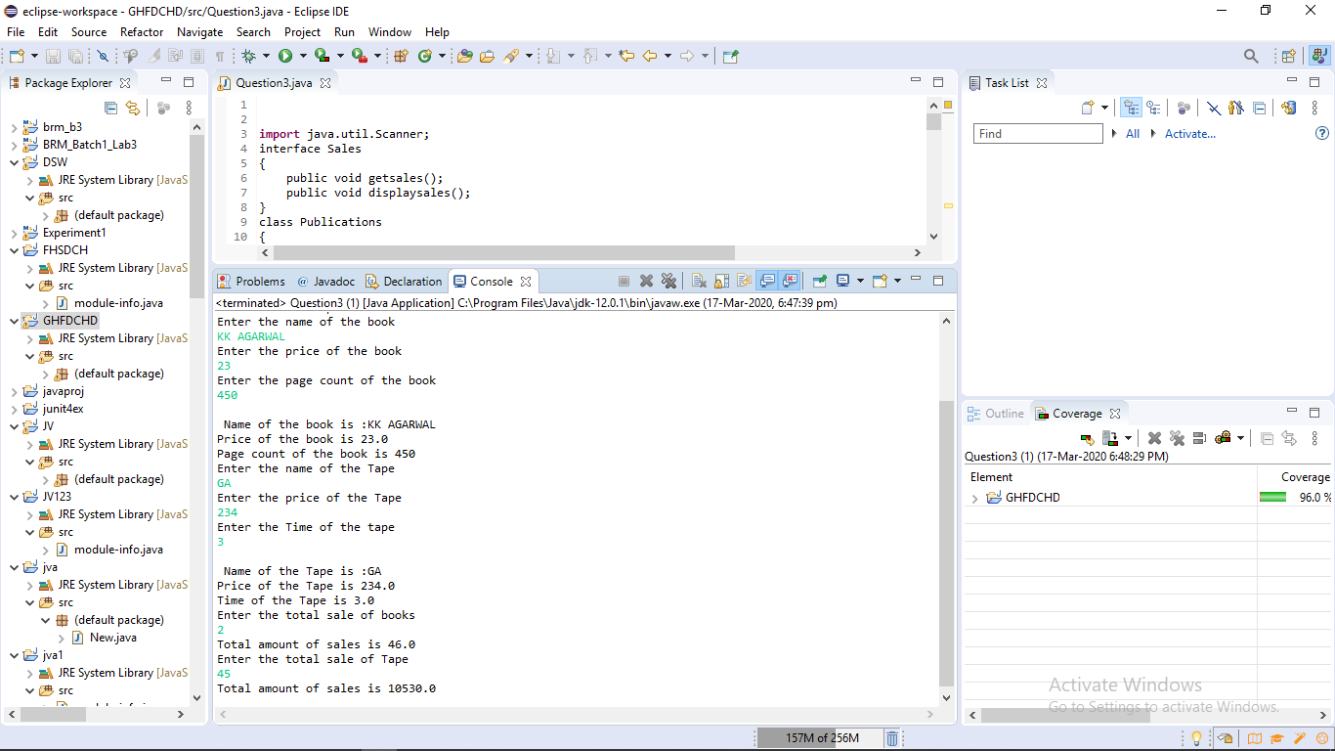

Q.4 Assume that a bank maintains two kinds of accounts for customers, one called as savings account and other as current account.

Solution:-

import java.util.Scanner;

import java.lang.Math;

import java.util.Random;

class Account

{

Random r = new Random();

Scanner sc = new Scanner(System.in);

String name;

int accno;

String type;

double balance;

void input()

{

System.out.println("Enter Name");

name=sc.nextLine();

sc.nextLine();

System.out.println("Account number Assigned");

accno=r.nextInt(10000);

System.out.println("Enter the type of account");

type = sc.nextLine();

sc.nextLine();

System.out.println("Enter the balance");

balance = sc.nextInt();

}

void display()

{

System.out.println("Name :: "+name+"\nAccount number :: "+accno+"\nType :: "+type+"\nBalance :: "+balance);

}

void deposit()

{

int amt;

System.out.println("Enter the amount u want to deposit");

amt = sc.nextInt();

balance= balance +amt;

}

}

class Saving_account extends Account

{

Scanner s = new Scanner(System.in);

double interest;

double compound()

{

int time,rate;

rate=10;

System.out.println("Enter the Time ");

time=s.nextInt();

interest = balance*Math.pow(1+rate/100.0,time)-balance;

return interest;

}

void update_balance()

{

balance= balance + compound();

}

void withdrawal()

{

int am;

System.out.println("Enter the amount to withdrawal");

am = s.nextInt();

if(balance >= am)

{

System.out.println("Withdrawal Successfull :: Balance updated");

balance= balance - am;

}

else

{

System.out.println("Ypour balance is low, can not withdraw");

}

}

}

class Current_account extends Account

{

Scanner s = new Scanner(System.in);

int chequebook,penalty;

int minimum()

{

int r=1;

if(balance <= 500)

{

penalty=50;

balance=balance-penalty;

r=0;

}

else

{

System.out.println("No penalty ");

}

return r;

}

void withdrawal()

{

int amount;

System.out.println("Enter the amount u want to withdraw");

amount= s.nextInt();

int count=minimum();

if(count == 1)

{

if(balance > amount)

{

balance = balance - amount;

System.out.println("Withdrwal Sucessful");

}

}

else

{

System.out.println("Because of minimum balance u cannot withdraw");

}

}

}

public class Question4 {

public static void main(String[] args)

{

Current_account c1 = new Current_account();

Saving_account s1 = new Saving_account();

c1.input();

c1.display();

c1.deposit();

c1.display();

c1.withdrawal();

c1.display();

s1.input();

s1.display();

s1.deposit();

s1.display();

s1.withdrawal();

s1.display();

double ss= s1.compound();

System.out.println("Compound Interest Is "+ss);

}

}

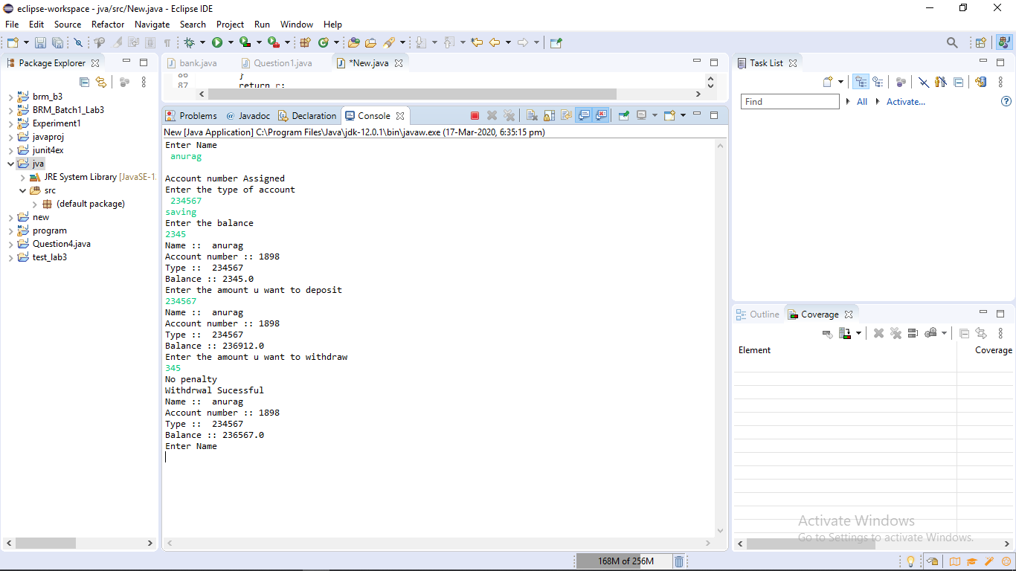

Bibliography:-

The Java Programming Language By Ken Arnold

A programmer’s guide to Java SE 8 BY Mughal

The Java Language Specification BY Gosling

References:-

GeeksForGeeks

Javatpoint

W3school